**I. Pen-and-paper**

**Answer 1**

Cluster 1

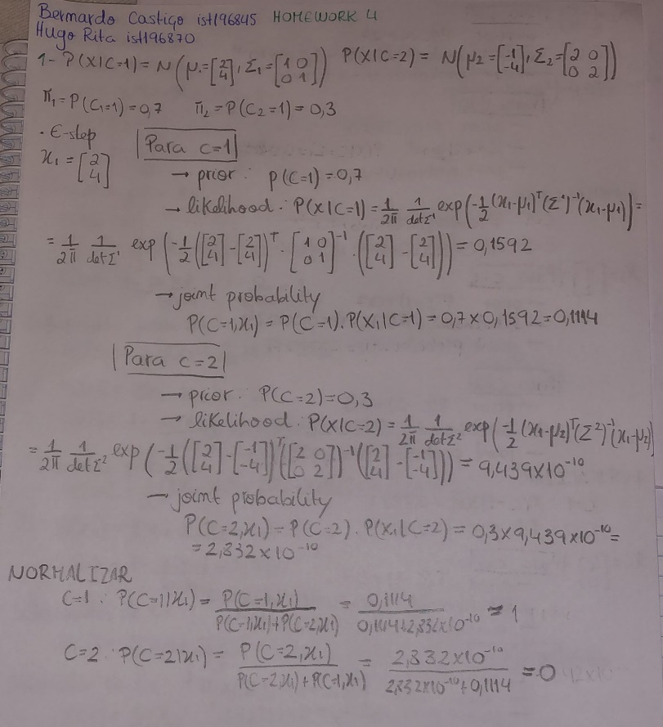

-3.4176

-0.3837

Cluster 2

1,5654

2,1007

1

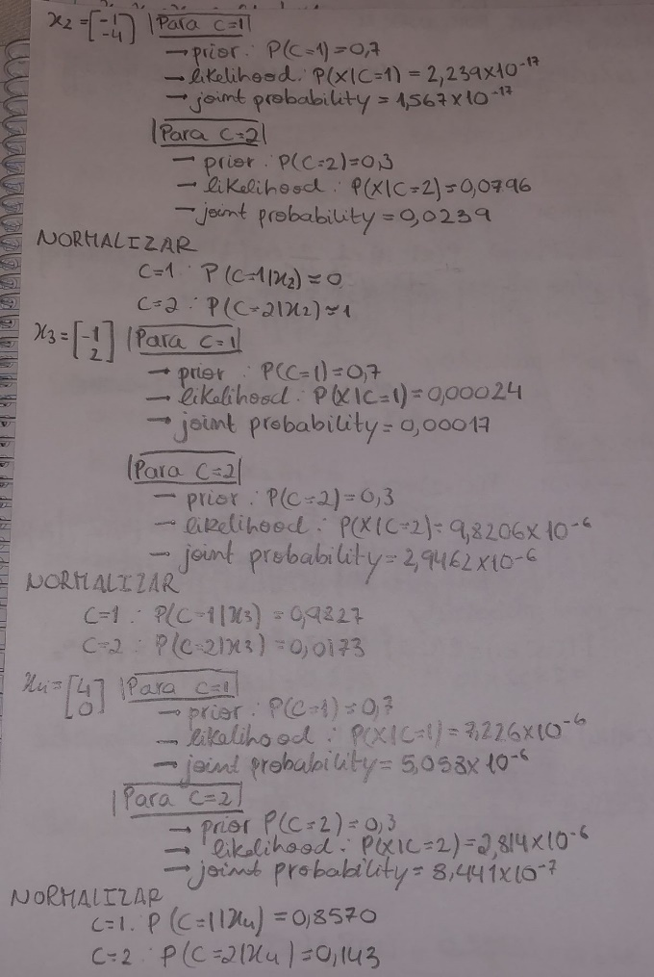 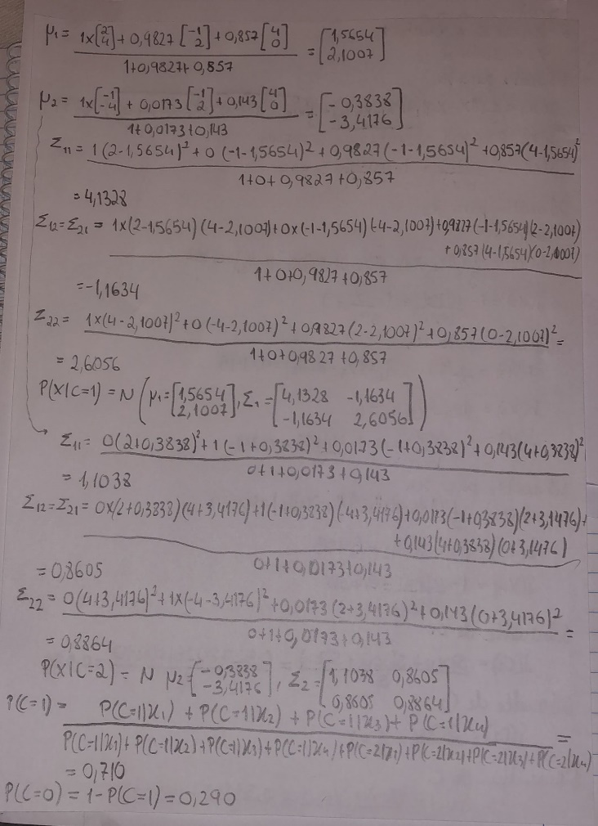

3

2

**Answer 2**

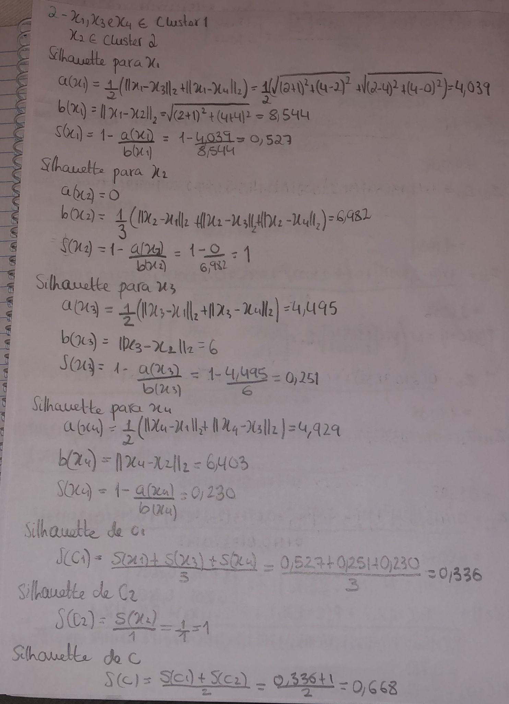

**Answer 3-a**

**i-**

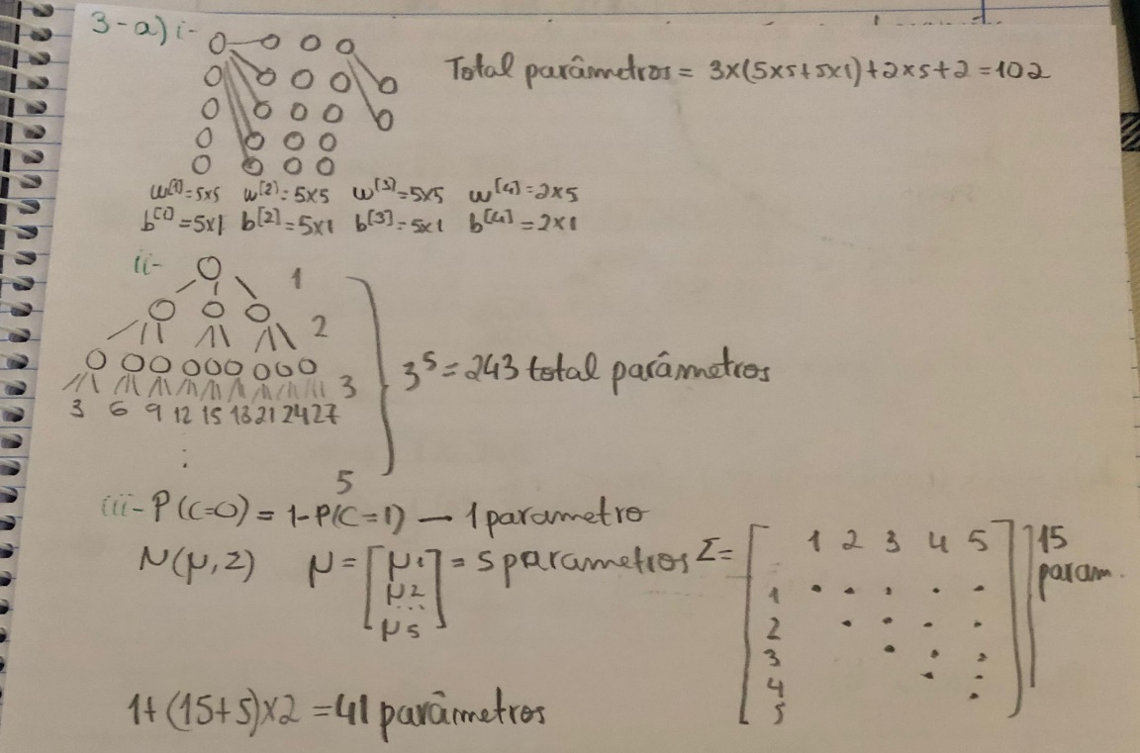

**ii-** 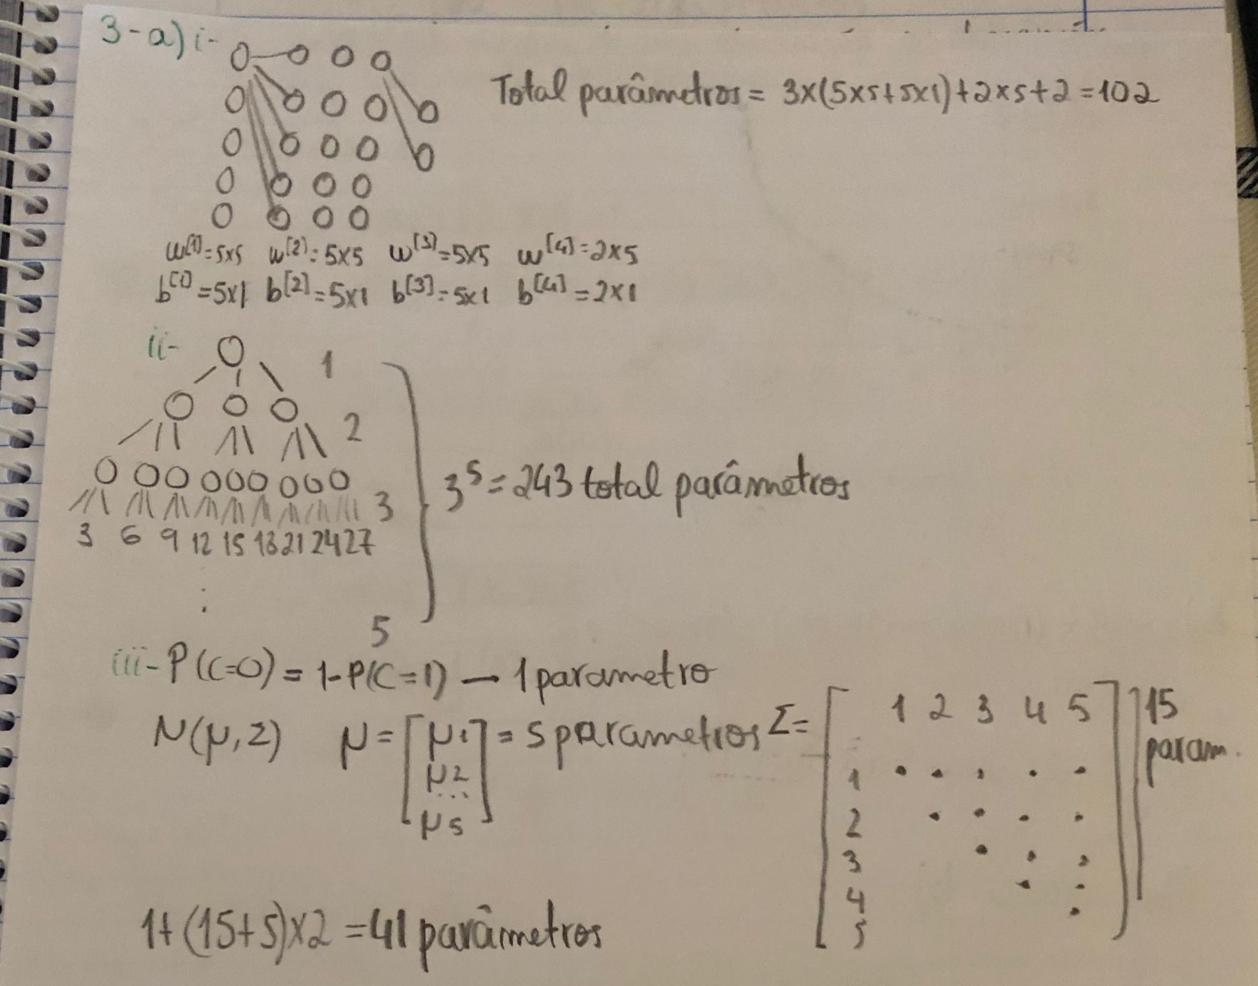

**iii-**

**Answer 3-b**

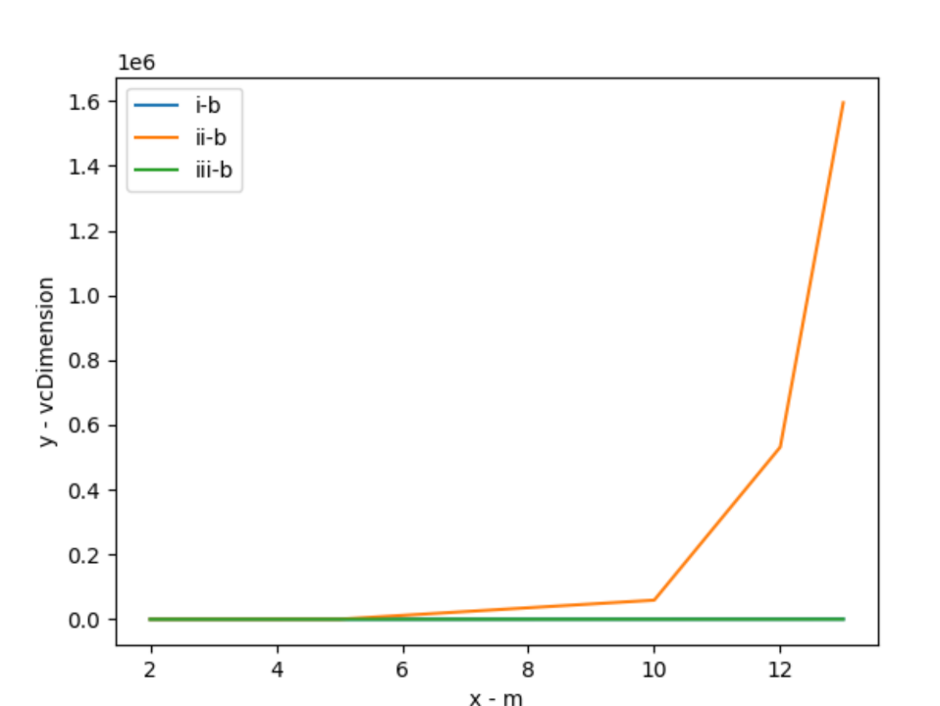

**Answer 3-c**

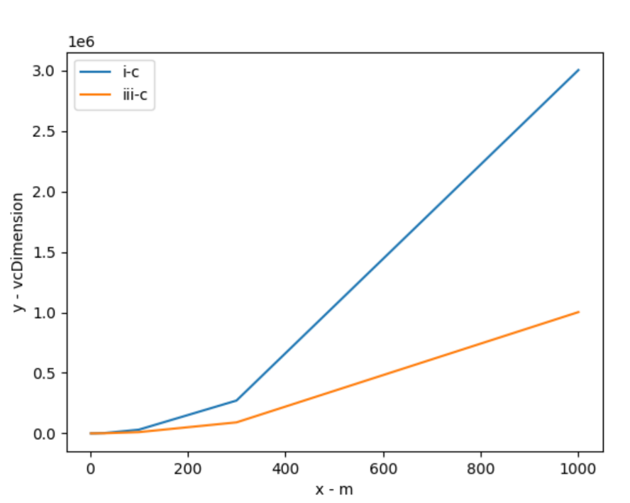

**Answer 4**

**II. Programming and critical analysis**

1. Answer 5
2. Answer 6
3. Answer 7
4. Answer 8

**III. APPENDIX**

Paste your programming code here using Consolas 9pt or 10pt.

Use **highlighting** or colored text to facilitate the analysis by your faculty hosts.

**END**